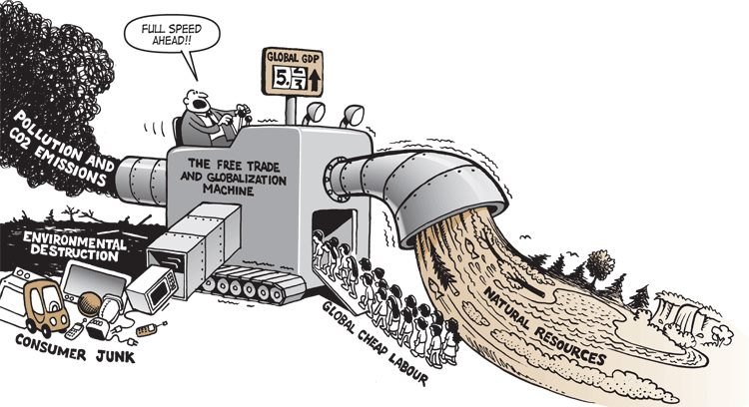

http://howtosavetheworld.ca/2013/07/15/links-of-the-month-july-15-2013/
globalization cartoon posted online; original source unknown

Additional Sources:
Advantages article: http://www.buzzle.com/articles/advantages-of-globalization.html
Globalization 101 http://www.globalization101.org/issues-in-depth/

