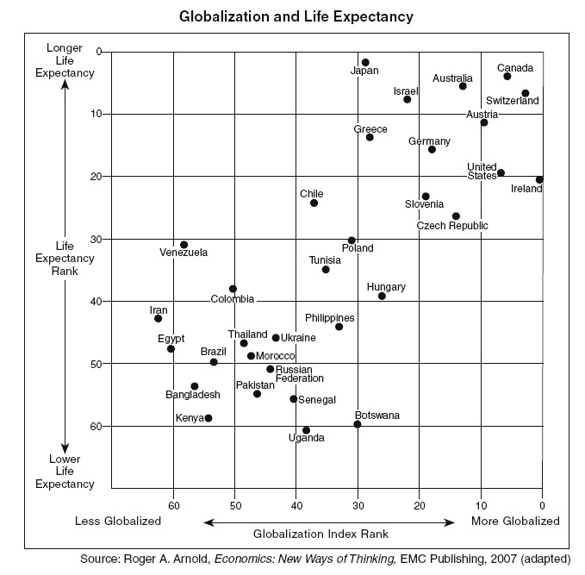
Name:__________
Block:_______

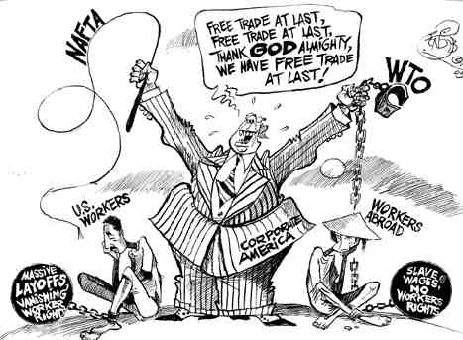
“Free-trade Cartoon.” WorldSocialism.org. http://www.worldsocialism.org/spgb/feb06/images/Free-trade%20cartoon.jpg (accessed April 18, 2009).

China's spectacular economic progress has not come without costs. The country's environment has suffered enormously as factories pop up everywhere and 2,000 new cars hit Beijing's roads each day. Pollution in Chinese cities is among the world's worst, with air so contaminated that children are often warned not to play outside.
The working conditions for many Chinese are also a concern. Millions of people have left the countryside to crowd into cities for factory jobs making the shirts and sneakers and cellphones that the rest of the world buys. Many of them work 12 hours a day, 7 days a week, earning as little as $150 a month.
Source: Wines, Michael, The Rise of China, The New York Times Upfront. September 5, 2011
Nations achieved large advances in life expectancy, nutrition, and education in the 20th century, and in the more equal distribution of them. Less widely noted is that over the last thirty years or so, the majority of the world's poor have begun slowly to catch up with living standards in developed countries for the first time in over two centuries. So far, the convergence is only relative (that is, the average person in a poor country has faster income growth than the average person in a rich country). Absolute (dollar) income gaps are still widening. But catch-up is clearly apparent when correctly measured in terms of the purchasing power of average national income per head.
The continued improvements in living standards and the recent reduction of inequality follow the return in the second half of the 20th century to widespread peace, sustained global economic growth, and freer global markets in trade and investment. Other influences include the decline since the late 1970s in the application of central planning and other statist development models.
China and India together account for almost 40 per cent of the world's population and both were formerly extremely poor. While they remain very poor, their rapid recent economic progress, consequent on their policy reforms of the last two decades, bulks large in today's improved global inequality statistics. Moreover, many other populous economies including Pakistan, Bangladesh, Indonesia and the other Asian 'tigers' have all experienced strong real per capita GDP growth over the last few decades, notwithstanding the Asian crisis of the late 1990s.
Source: From “Global Poverty and Inequality in the 20th century: Turning the Corner?,” an article prepared in 2001 for the Treasury Department of the government of Australia. Http://www.treasury.gove.au/documents/110/PDF/Round2.pdf

As the standard of living in the United States increased, many companies found it was cheaper to locate call centers overseas. Countries like India, Ireland, Canada and the Philippines were the most popular. Not only were workers paid much less, but they already spoke English. For example, an U.S. call center employee, including labor, technology and phone routing, costs a company $20 per hour on average versus $12 per hour in India. From 2001-2003, over 250,000 call center jobs were outsourced to India and the Philippines alone.
Source: “How Does Call Center Outsourcing Affect the U.S. Economy?”
http://useconomy.about.com/od/suppl1/f/How-Call-Center-Outsourcing-Affects-Economy.htm
Source: Technology Manufacturing Corp

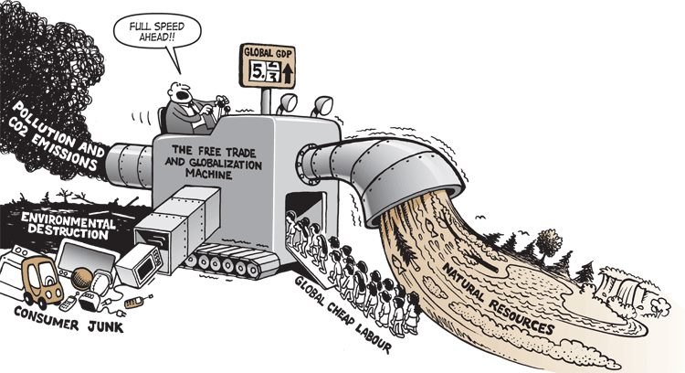

http://howtosavetheworld.ca/2013/07/15/links-of-the-month-july-15-2013/
globalization cartoon posted online; original source unknown

Additional Sources:
Advantages article: http://www.buzzle.com/articles/advantages-of-globalization.html
Globalization 101 http://www.globalization101.org/issues-in-depth/

