Human-Environmental Interaction Name: ____________
The Lorax by Dr. Seuss
- Character Webs: As you view the movie, complete the webs by inserting adjectives to describe the two main characters in the circles.

The Lorax
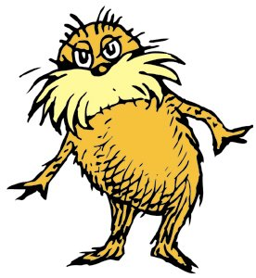

The Once-ler
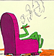

- As you view look for the causes and effects of the following events in the story.
Causes | Effects
Example: Once-ler comes and see the Truffla Trees | He unloads his wagon and builds a shop.
 | Lorax appears
A man buys the first thneed for $3.98

Invention of Super-Axe-Hacker

 | Brown Bar-ba-loots leave
 | More roads, loads and wagons
Smogulous smoke
 | Humming-Fish leave
The last Truffla-Tree falls
 | Things will get better!
Author’s Purpose: Why did Dr. Seuss write this story?

How can you apply his message to your life?

Problem/Solution Poster

- No larger than 8.5 x 11
- Must clearly identify an environmental problem of today
- Must clearly identify a feasible solution to the problem
- Includes symbols and illustrations
- Colored

